Setting Up macros on the system

Note: The below setup can be done on any Excel workbook, there is no need to open a specific macro file.
Open Excel Workbook à Click on File à Options à Trust Center à Trust Center Setting à Macro Settings à enable macros for this workbook à Select options present in the below screenshot >>>

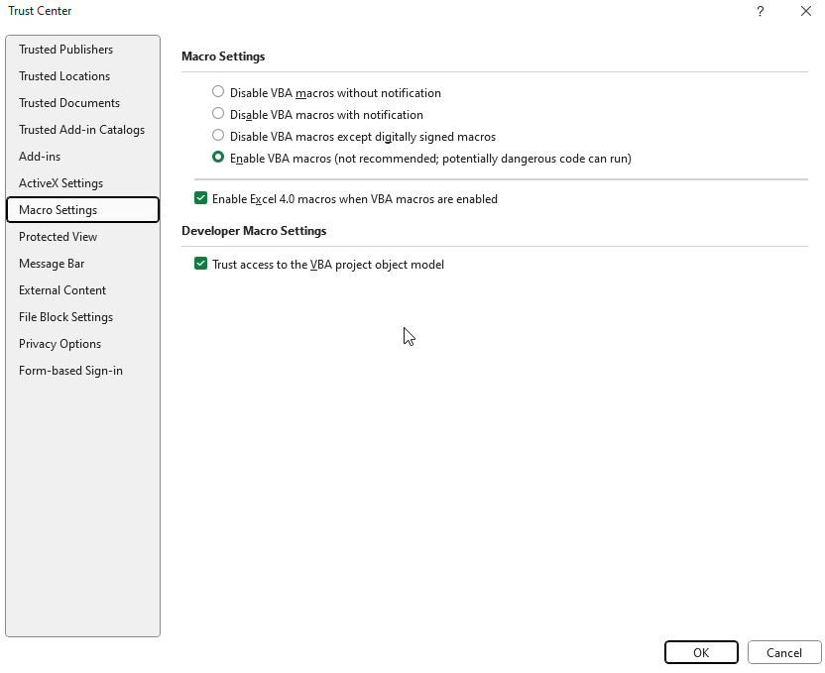

Setting up the ribbon in Excel

With the Excel workbook already open, follow these steps:
Go to File → Options → Click Customize Ribbon (Step-1) à Under the Main Tabs, locate Automate. Select that (Step-2) à Click on New Group and rename it 'Macro'. Press OK. à (Step-3) Then, under Popular Commands, find and select Macros. Click Add (Step-4) >> and finalize by clicking OK and closing all windows.

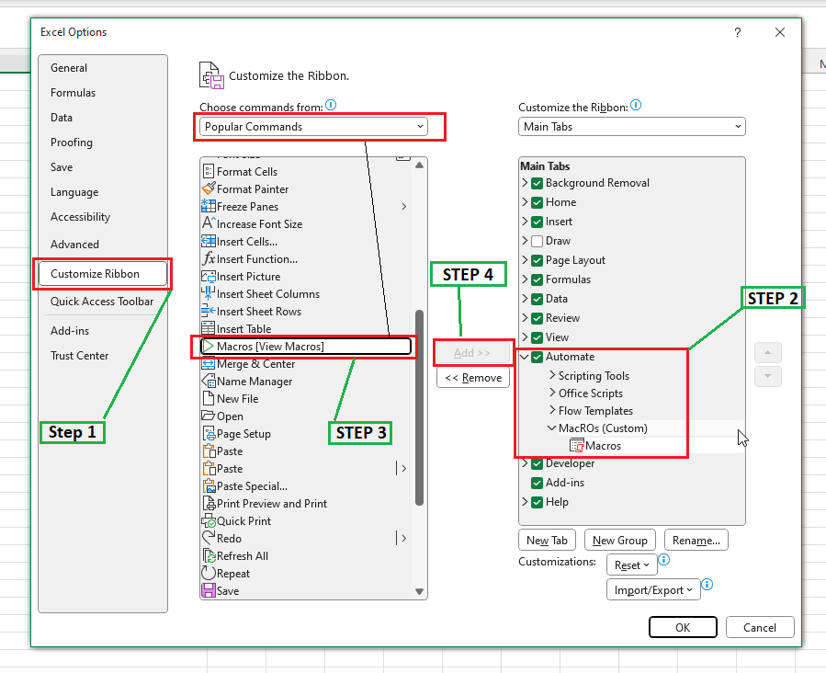

SVN Checkout for SEM Automation Scripts.
- Locate the “Genentech” folder on the system (where other web scripts are present)
- Right click Click on SVN Update.
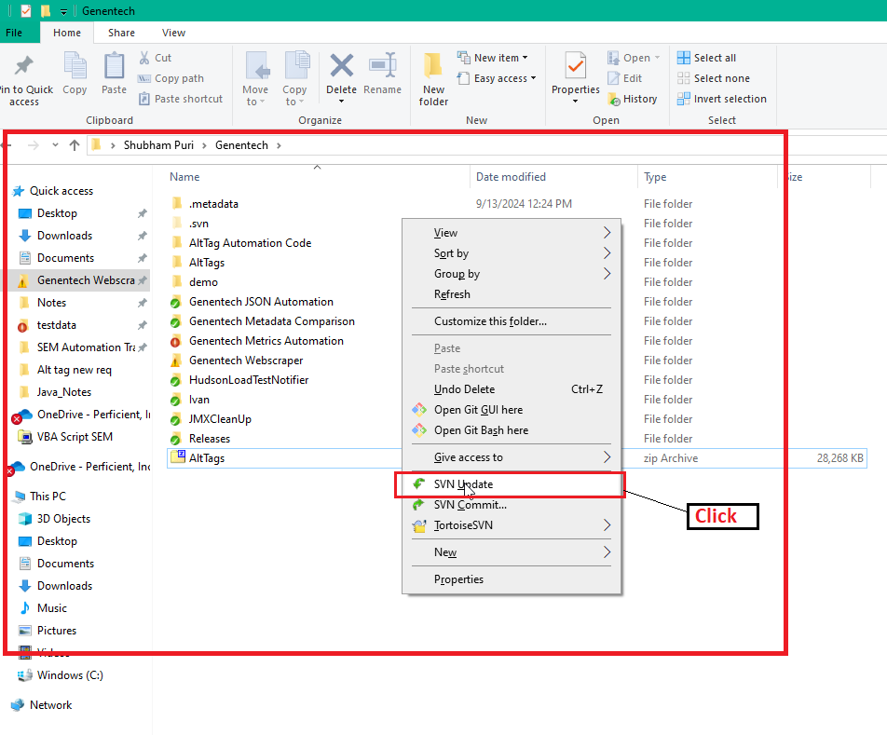
- The “SEM Automation Scripts” folder was added.

Allowing access to VBA macros file for script execution
Note: This is a one-time permission that you need to provide.
Open File Explorer à navigate to the folder where you did SVN checkout à Locate the “VBA Macros Script” Excel File in the “SEM Automation Scripts” folder” à Right click à Click on Properties à Select Unblock Checkbox à Click on Apply + Ok

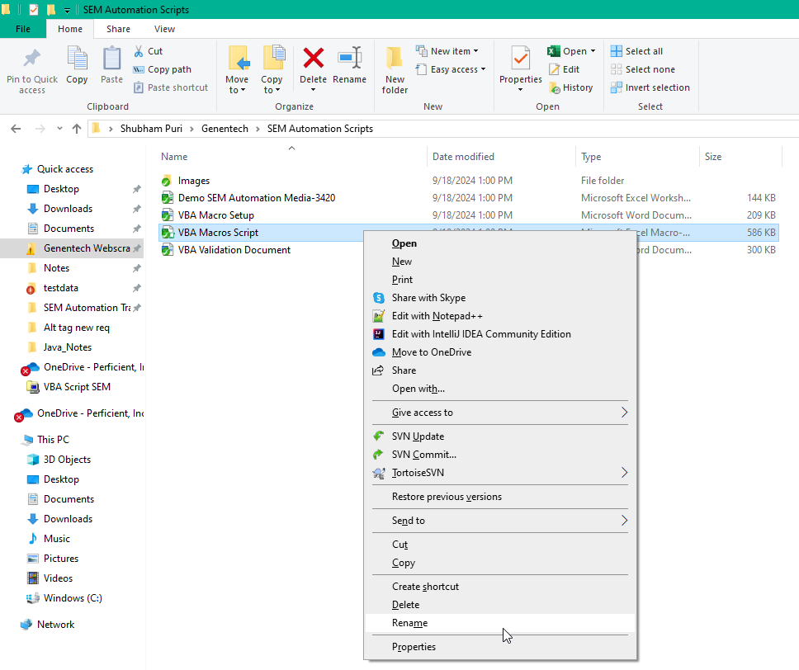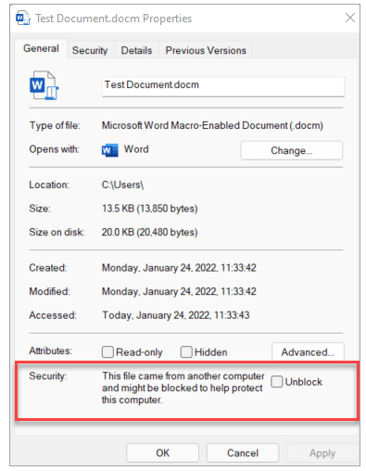

Links for Reference
- Enable or disable macros in Microsoft 365 files
- Allowing access to VBA macros file for script execution

